* 1. **Purpose and Scope**

The purpose of this document is to explain the Project Plan devised for the

system to be. All the people involved in the project could be considered as

possible readers of the document, but the document itself is more of a guide

for the Project Manager and the Management in general. The Project Plan

consists in tables, Gantt diagrams, charts and natural language descriptions of

the planning, scheduling and management of PowerEnJoy development.

* 1. **List of Definitions and Abbreviations**
  2. **List of Reference Documents**

**2.Function Points**

The Functional Point approach is a technique that allows to evaluate the effort needed for the design and implementation of a project. We have used this technique to evaluate the application dimension basing on the functionalities of the application itself. The functionalities list has been obtained from the RASD document and for each one of them the realization complexity has been evaluated. The functionalities has been groped in:

_ Internal Logic File: it represents a set of homogeneous data handled by the system

_ External Interface File: it represents a set of homogeneous data used by the application but handled by external application

_ External Input: elementary operation that allows input of data in the system

_ External Output: elementary operation that creates a bit stream towards the outside of the application

_ External Inquiry: elementary operation that involves input and output operations

The following table outline the number of Functional Point based on func-

tionality and relative complexity:

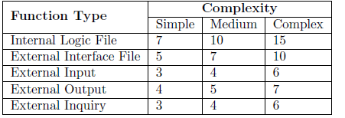

**2.2 Functional Point estimation**

**2.2.1 Internal Logic Files**

**2.2.2 External Logic Files**

**2.2.3 External Input**

**2.2.4 External Output**

**2.2.5 External Inquiry**

**2.2.6 Summary**

**3 Cocomo**

**3.1 Introduction**

**3.2 Scale drivers**

**3.3 Cost drivers**

**3.4 Schedule Estimation**

**4 Task and Schedule**

**4.1 Task**

**4.2 Schedule**

**5 Resources**

**6 Risk**

**Appendix**